**Topics :**

* **SQS (**Simple Queue Service**) :** {**Producer -> queue -> Consumer.** Visibility time} **\*\*imp\*\***

Standard queue [need to define Delivery Delay (time delay, so consumer won’t see message immediately), Dead Letter Queue(redrive policy mean if a message try process for x time and still not processed then it will be deleted) and Long Polling (wait for X time before making next call to queue from consumer.) ].

* **SNS** (Simple Notification Service) : **{Publisher -> topic -> Subscriber}**
* **Kinesis : {Producer -> shard -> Consumer}**

1. Shard: uniquely identify sequence of data records

**Introduction:** When there are more than 2 applications and they need to communicate asynchronously then we use these services like SQS, SNS or Kinesis.

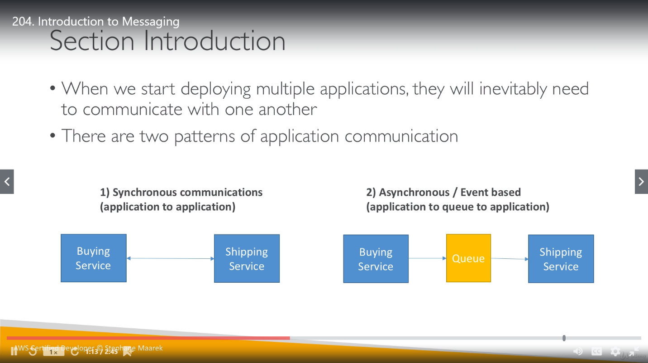

inevitably ( inˈevitəblē ) : अनिवार्य रूप से

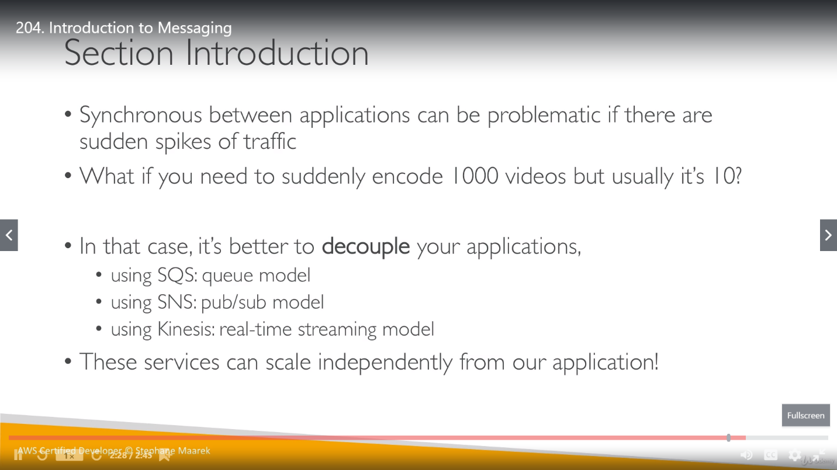

**SQS:**

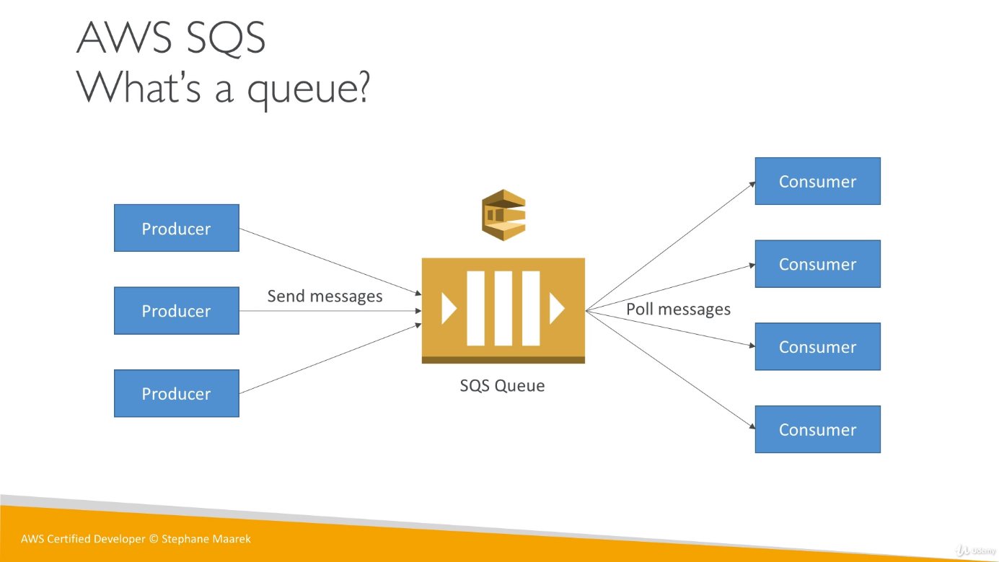

**Producing messages:**

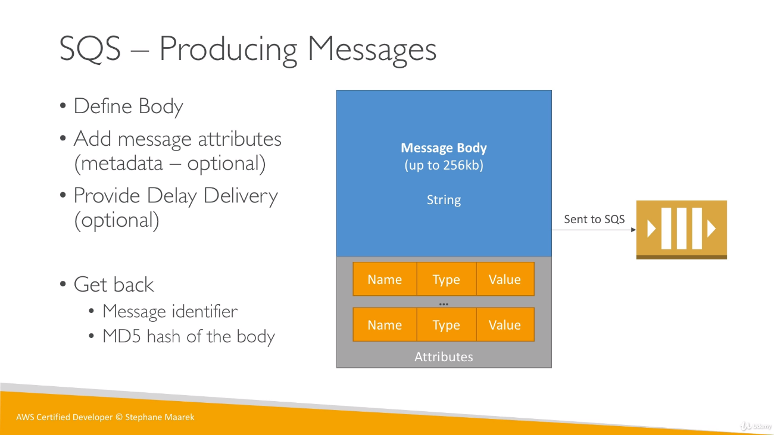

We get back message id and MD5 hash body (if we want to store body for future) for success delivery of message to queue.

**Consuming messages:** Message will not directly come from Producer to Consumer instead it will be polled from SQS. Consumer can consume up to 10 messages at a time, but these messages should be consumed within visibility time. Once the messages are received within visibility timeout, they will be deleted from Queue using message ID.(process called receipt handle)

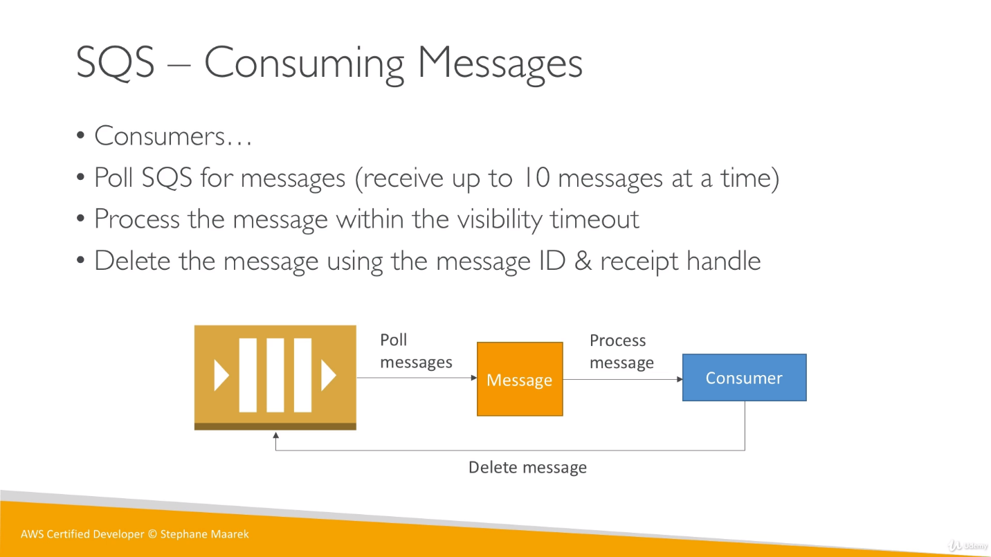

**Visibility Time:** for visibility time when a consumer is processing the message it won’t be visible to other consumer so message should be processed within Visibility timeout. We have to decide this time is such a way that message is processed successfully and there in not time wasted as well.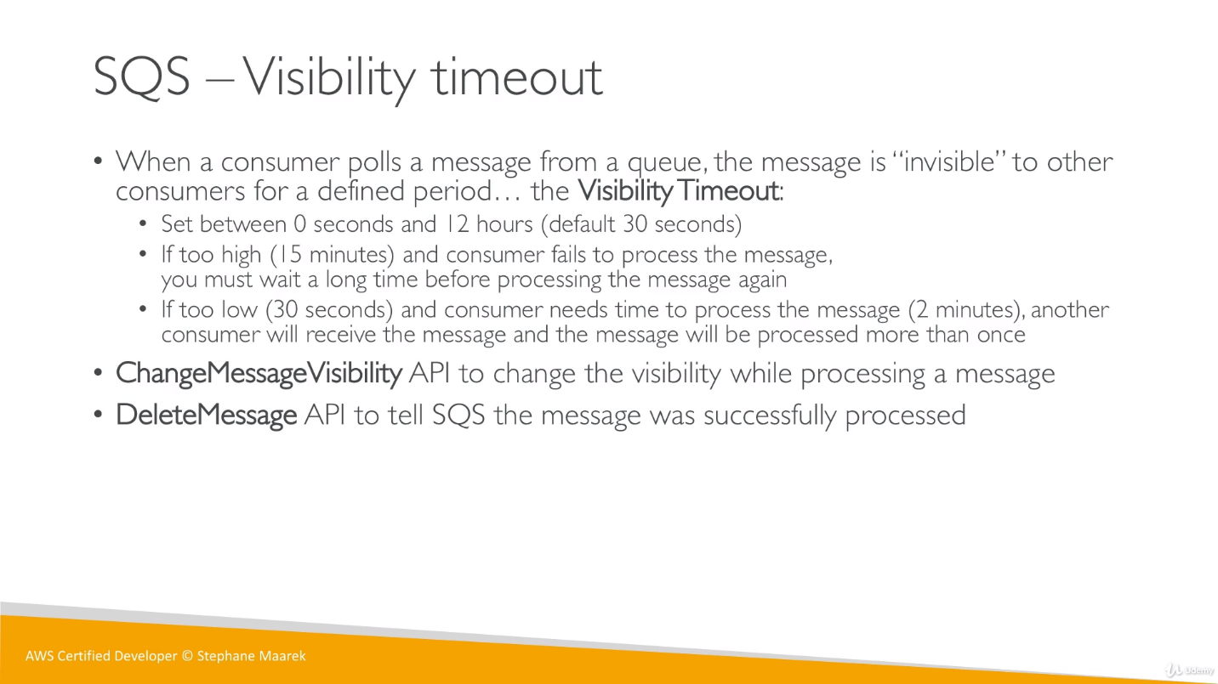

**AWS SQS Standard Queue:** We have to set few attributes for standard SQS as Delivery Delay, Dead Letter Queue and Long Polling (Receive message wait time).

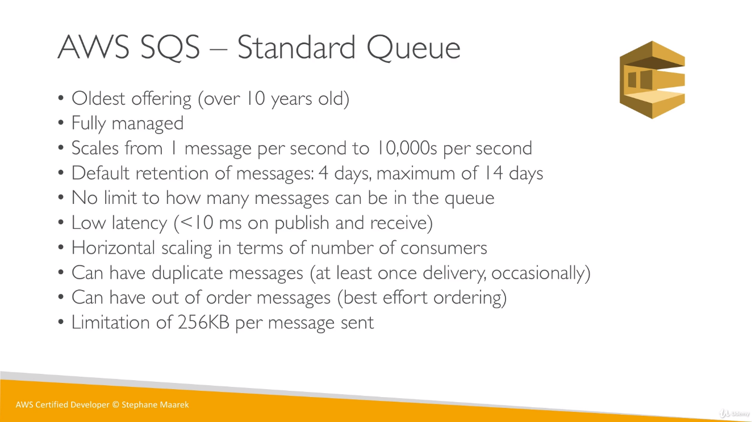

Although there is possibility of duplicate messages and message order mismatch but it’s very rare.

Sometimes we will get that producer is sending message twice, this is because it was designed to work for super high throughput.

Sometimes we can also have out of order messages this is also because of design.

**Delay Queue:**

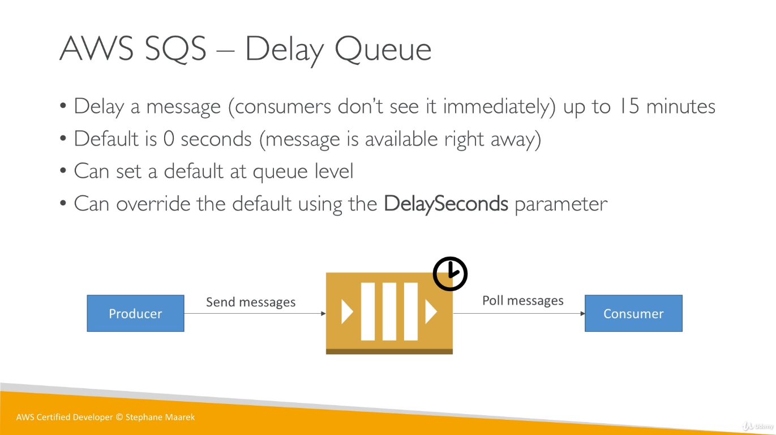

The size of queue is standard and can’t be increase, it’s 256 KB. So, we can’t use it for huge data like videos, its only for communicate between applications like JSON file.

**Dead Letter Queue (DLQ):**

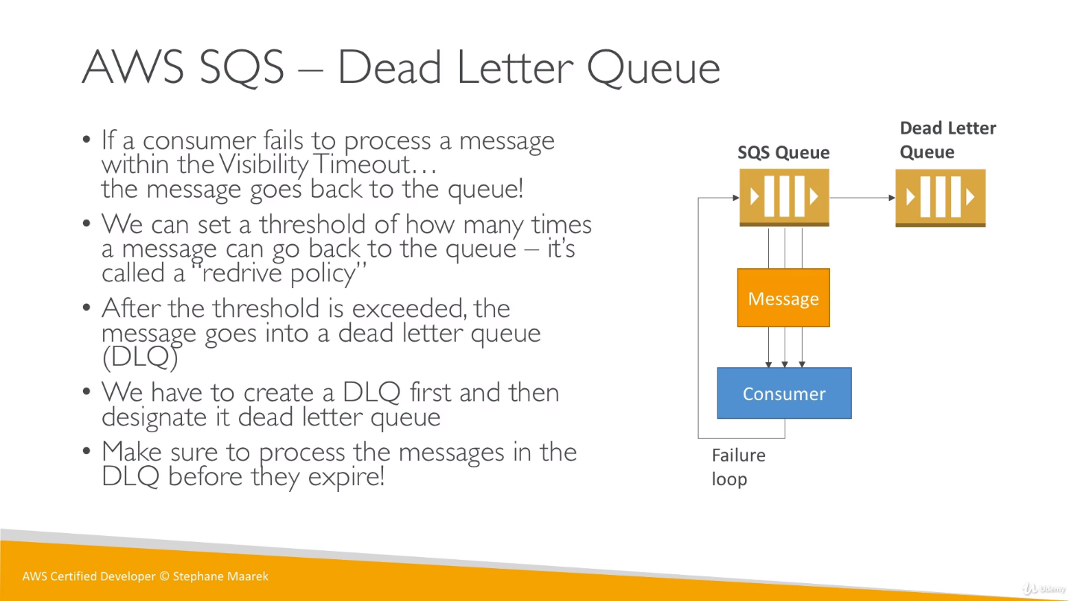

**Long Queue:** (receive message wait time)

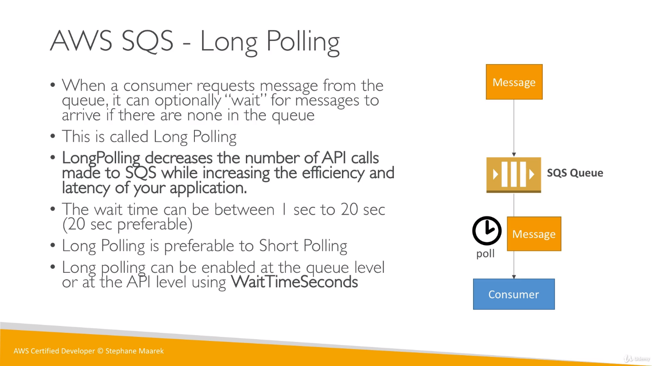

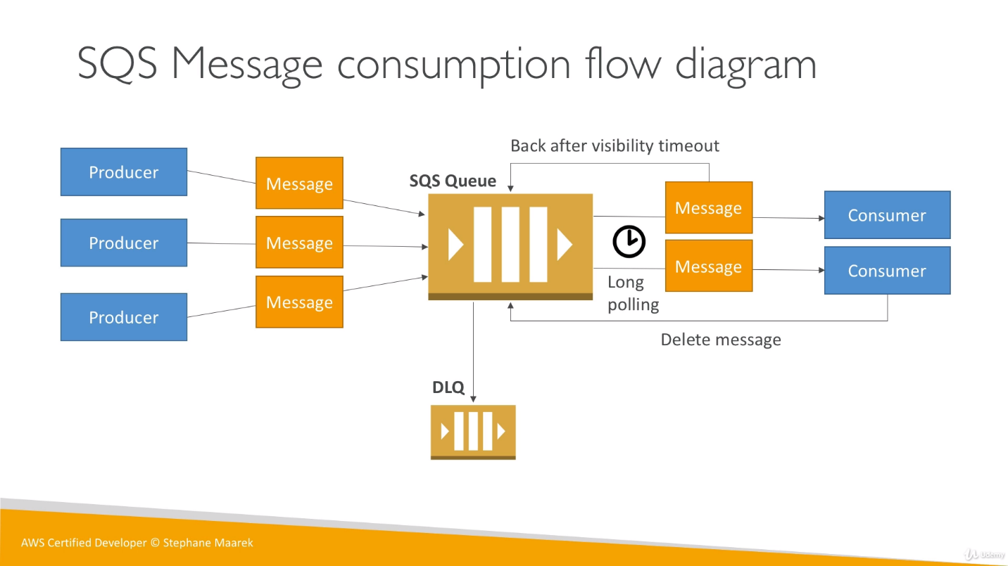

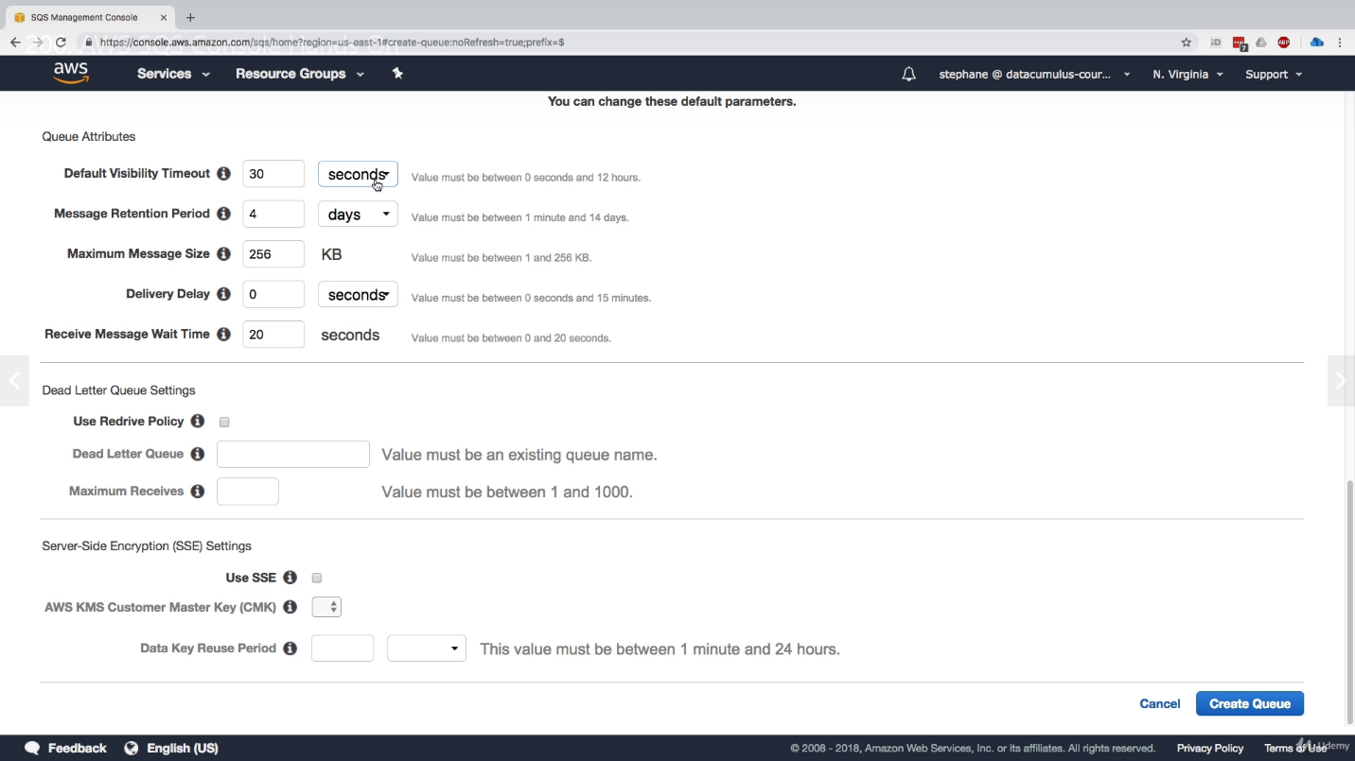

Once we created above Queue, we get below details:

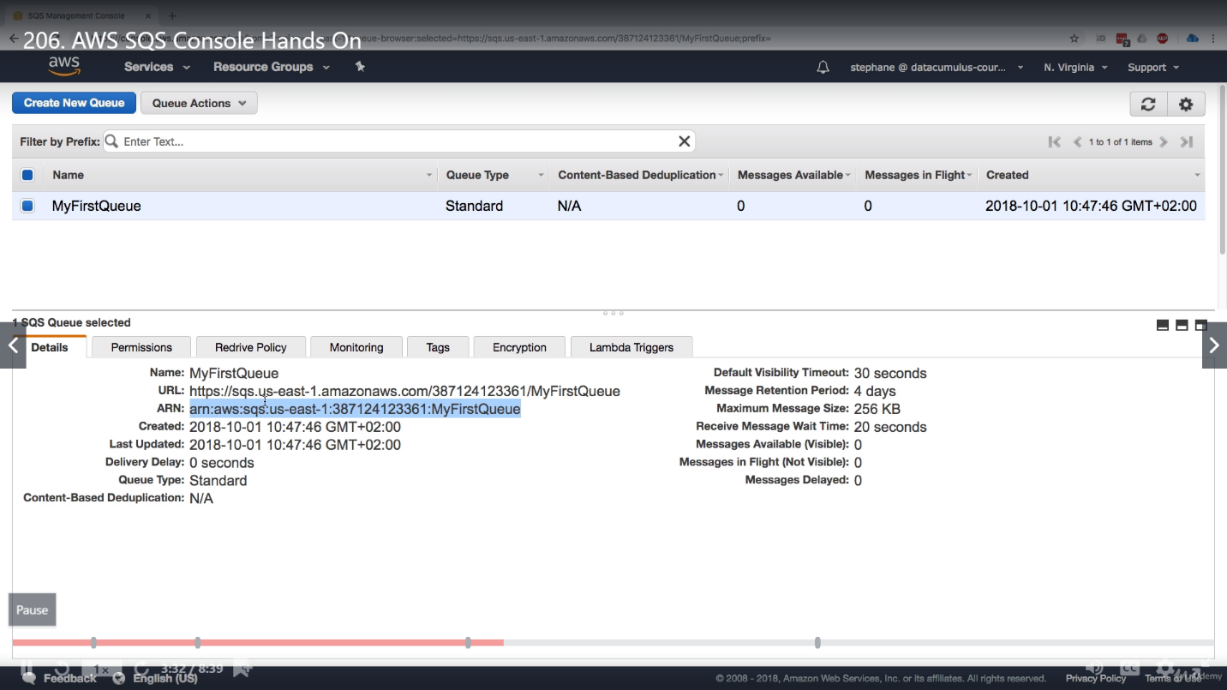

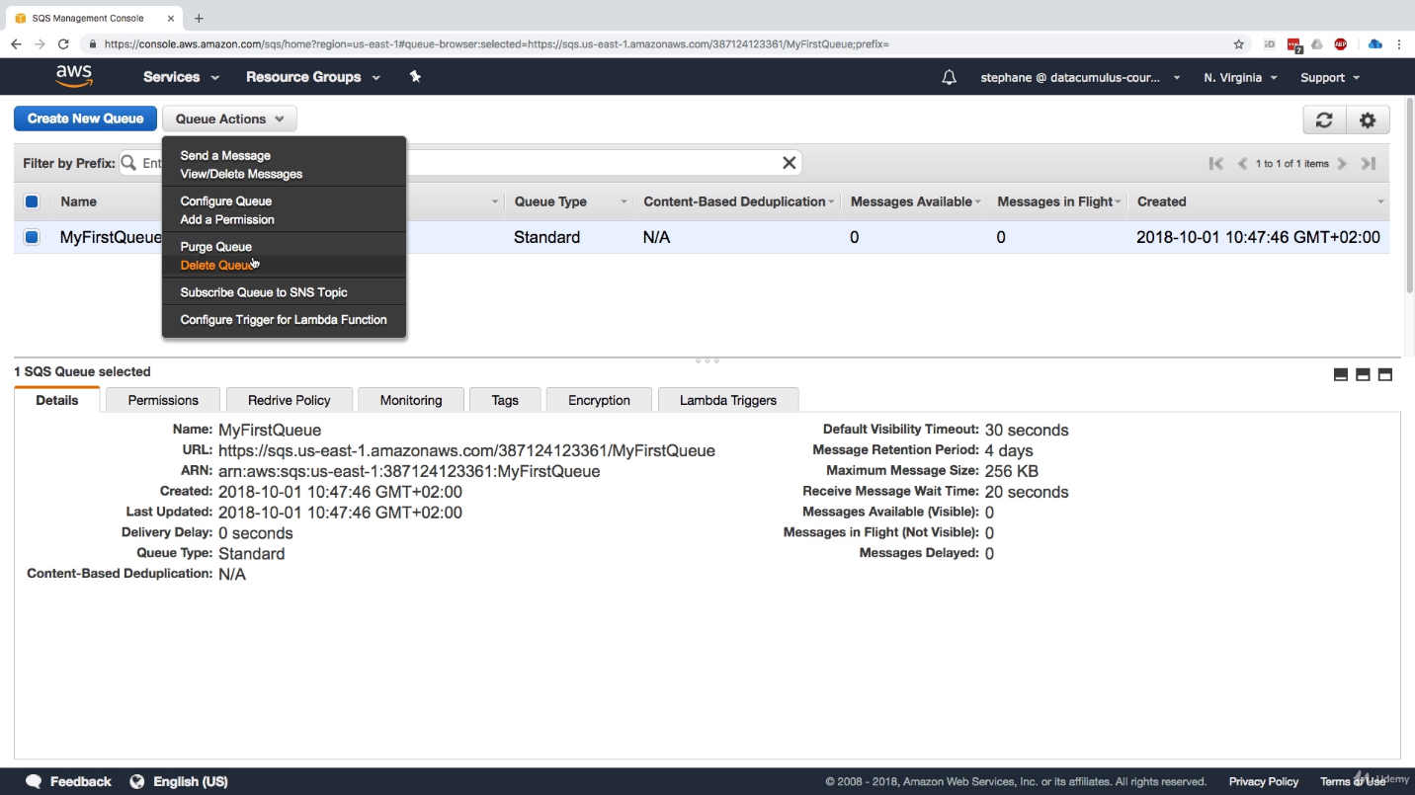

We have above options for a queue like send a message through queue, view/Delete a message, config/edit queue, purge (delete all messages) or delete Queue etc.

We have option of delay delivery at the time of sending message as well.

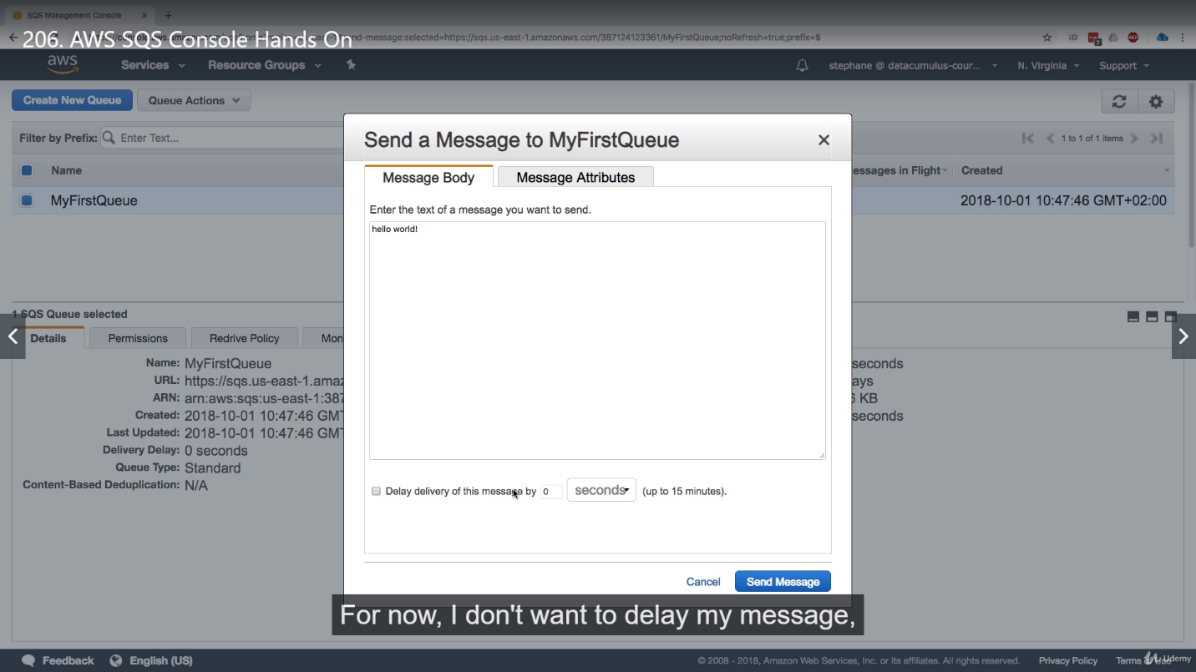

We can set message attributes as well before sending it (optional).

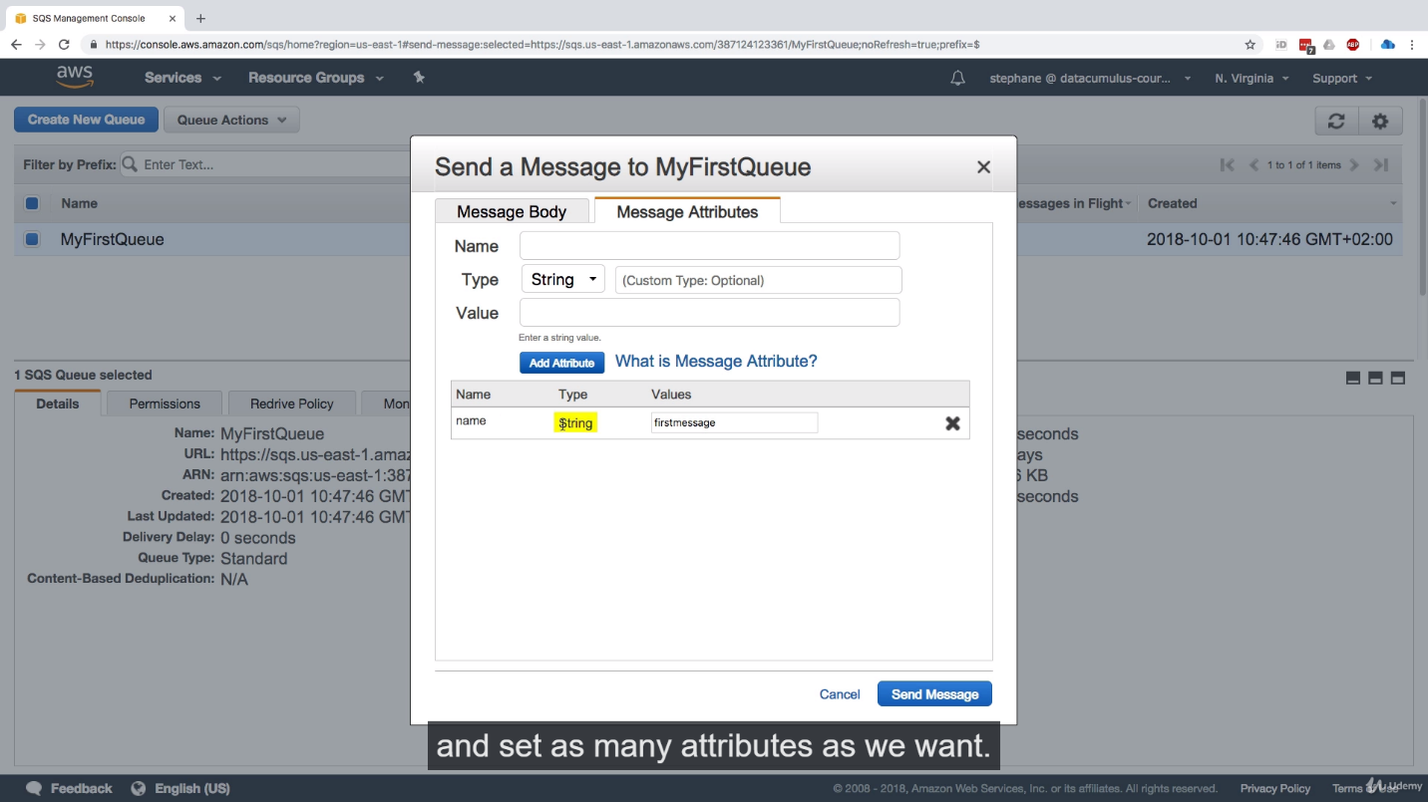

Once the message been sent, we got confirmation as message id, message body hash and message attribute hash.

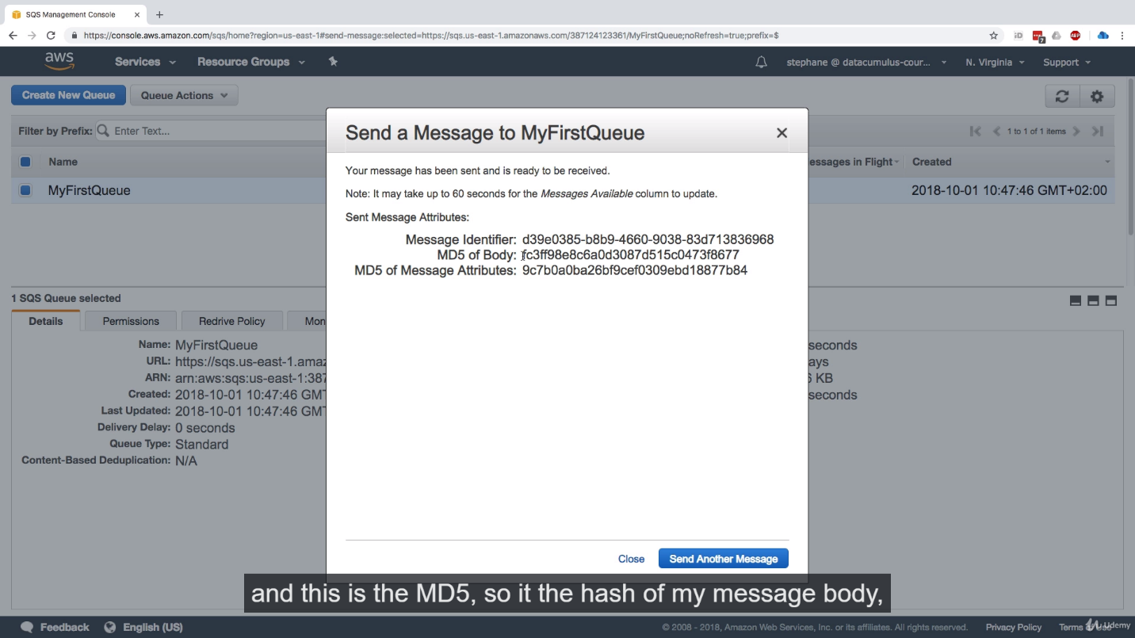

We can setup a Delete Letter Queue for any queue by defining Redrive policy (Maximum Receive), which means if a message is not processed after these attempts then it will go to DLQ.

**SQS Extension to send large Data:**

If we really require sending a larger data like a video, we can use a java library using which we will send the data directly to S3 bucket and we send only metadata to SQS Queue to inform that about it.

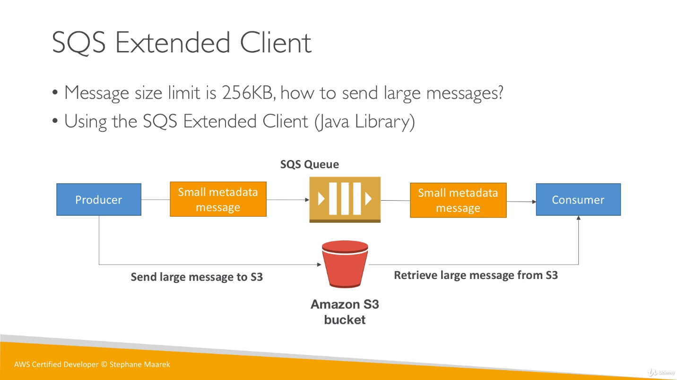

We can Encrypt SQS queue using HTTPS endpoints. We can enable Server Side Encryption using KMS.

**SQS APIs:**

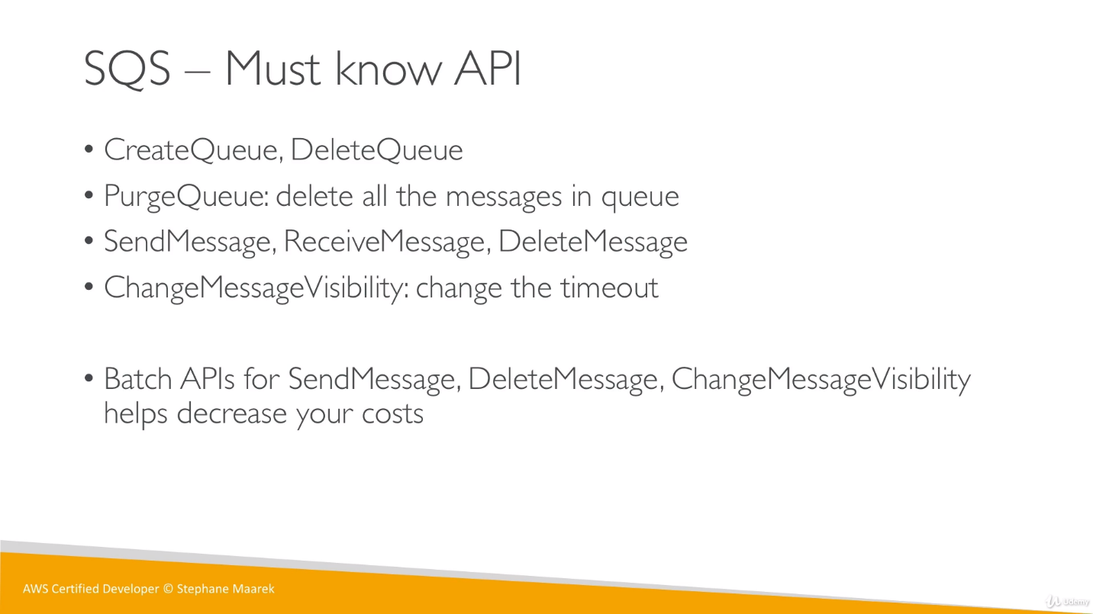

ReceiveMessage can receive up to 10 messages that’s why there is no Batch API for receive.

**AWS SQS FIFO Queue:** We can scale Standard SQS queue from 1 msg/sec to 1000 msg/sec, here we are reducing standard throughput as 300 msg/sec but increasing ***guarantee of ordering***.

We can’t define per message delay because if we do so, FIFO won’t guarantee of ordering so it allows only per queue delay not per message delay.

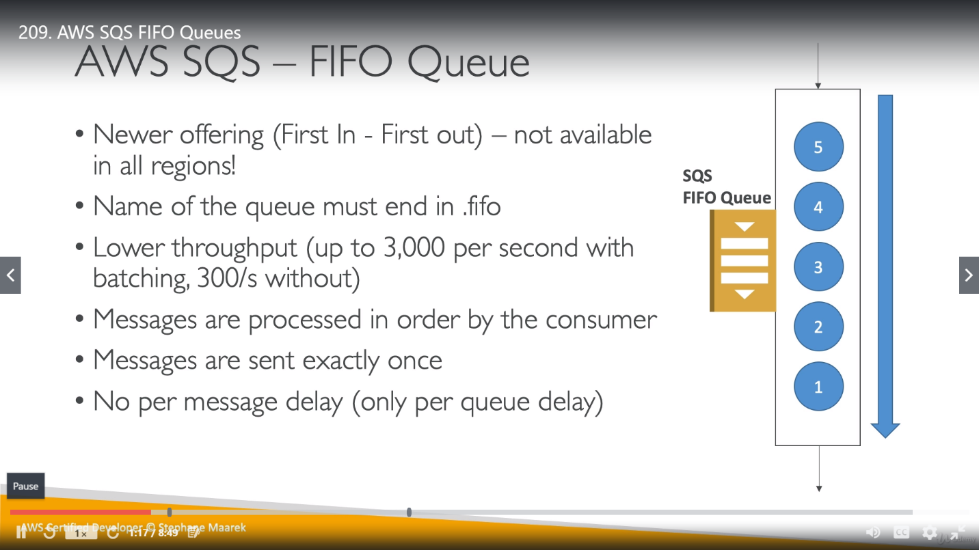

**Features:**

**Deduplication:** We use this concept when we want to send the same message twice. We have 2 ways,

Provide our own unique deDuplicationId or use SHA-256 hashing algorithm on body to generate it. So, it will prevent any message coming with same id for next 5 min.

**Sequencing:** To strict ordering between messages, we specify a MessageGroupId.

* Messages that have a different group id, may be received out of order.
* If we are sending messages to a single user and we want to maintain message ordering, then we can use user_id as groupId.
* If 2 messages are using same messageGroupId, they will be consumed in order. Whereas 2 messages having different groupId may be received in different order but may also be consumed by different user at a time.

While sending a message we required both Message Group Id and Message Deduplication Id. We can configure FIFO queue anytime like we want to enable SHA-256 algorithm for deDuplcation purpose (in this case we no need to provide Message Deduplication Id)

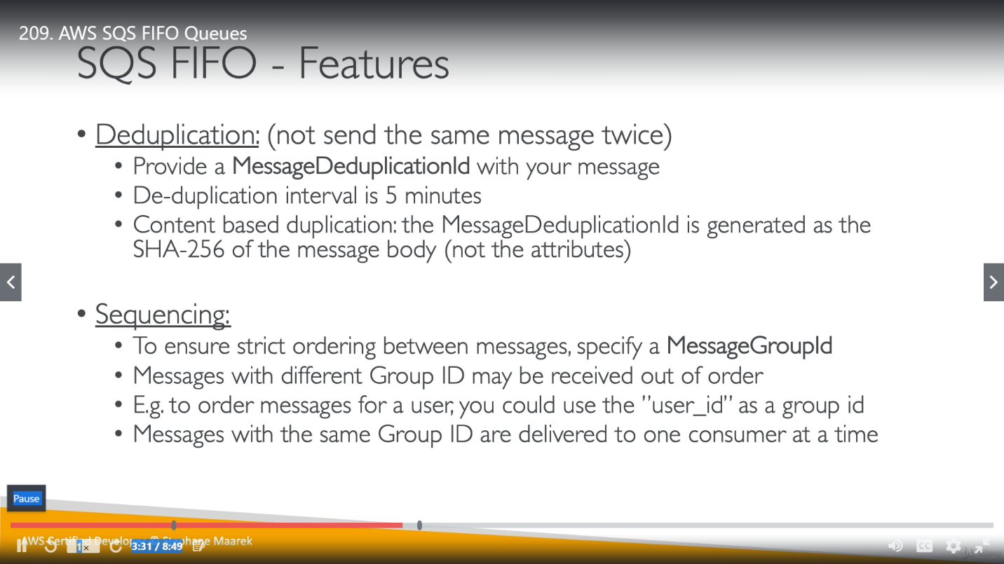

**Amazon SNS (Simple Notification Service):**

We create a topic for SNS service. Then we will create a Subscription which will listen to this topic.

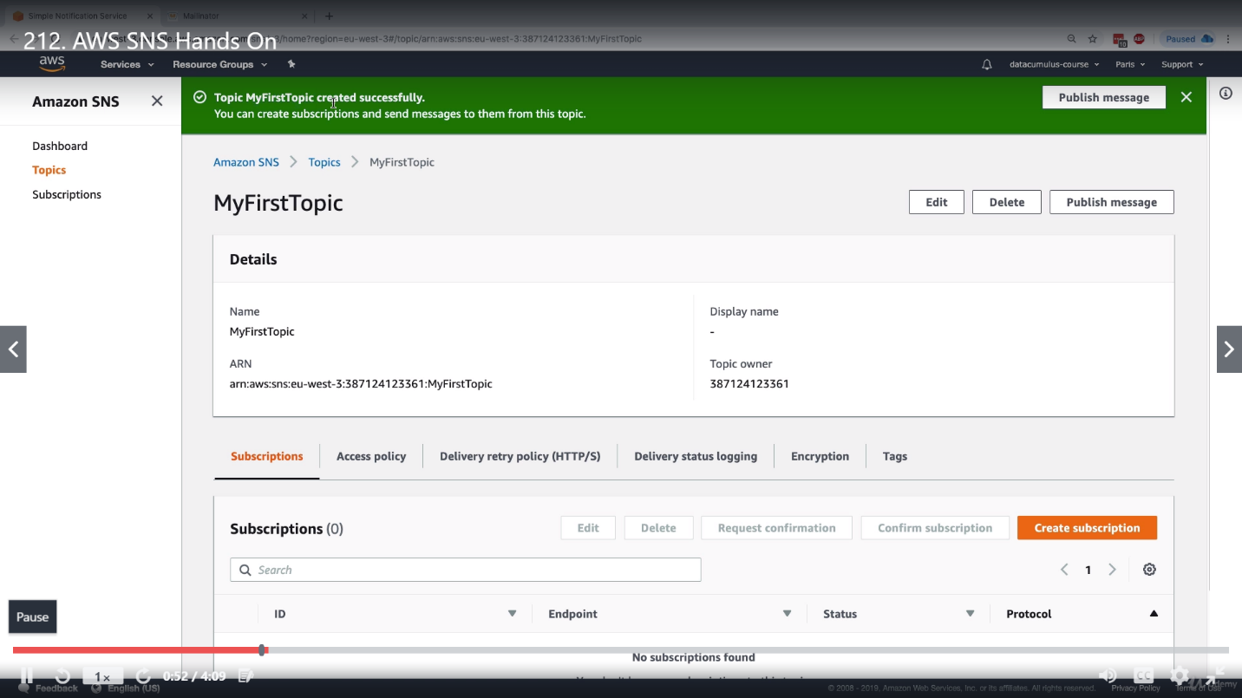

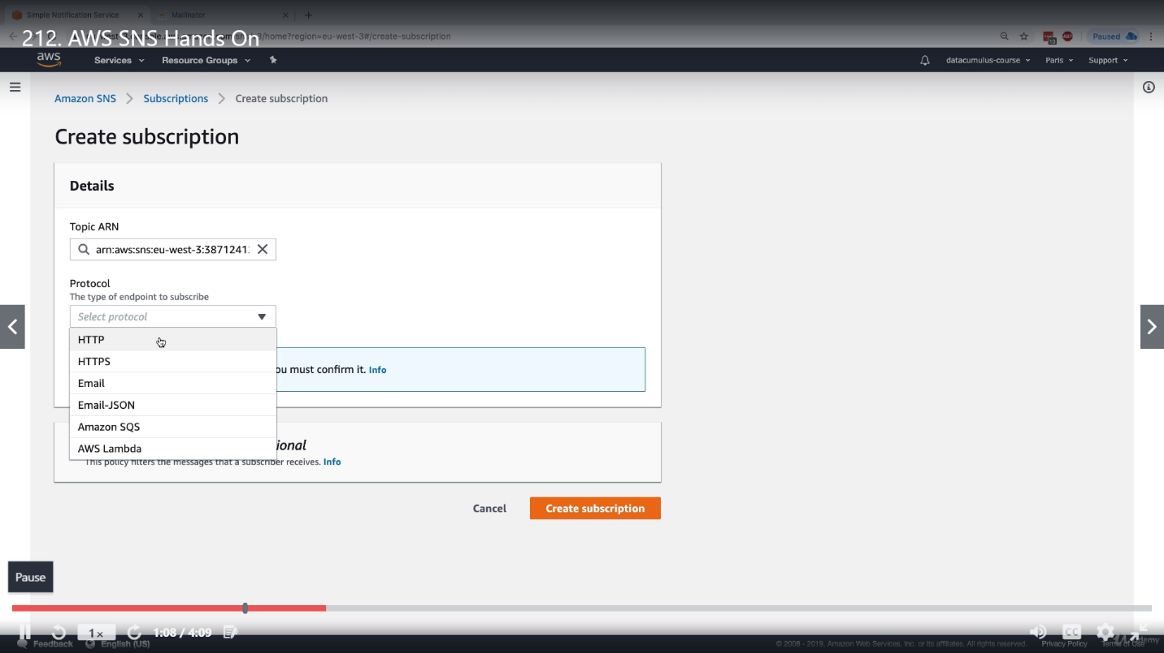

We have above mentioned protocol options while creating a Subscription. For example, we can send a mail to our mail id by choosing mail protocol.

**AWS Kinesis:**

It’s an alternative for Kafka and popular for exam. Its compatible with many Stream processing framework like Spark etc. The data coming to AWS Kinesis is replicated automatically to 3 Availability Zone AZ. So overall its helpful for Bigdata in real time.

There are 3 sub kinesis components.

**Kinesis Stream:** How to ingest (take down) streams at a scale with a low latency. This is called Kinesis as well and it’s important for exam.

**Kinesis Analytics:** This is to perform real time analysis (like computations, filter etc.) on streams using SQL.

**Kinesis Firehose:** To load stream into other part of AWS such as S3, ElasticSearch etc.

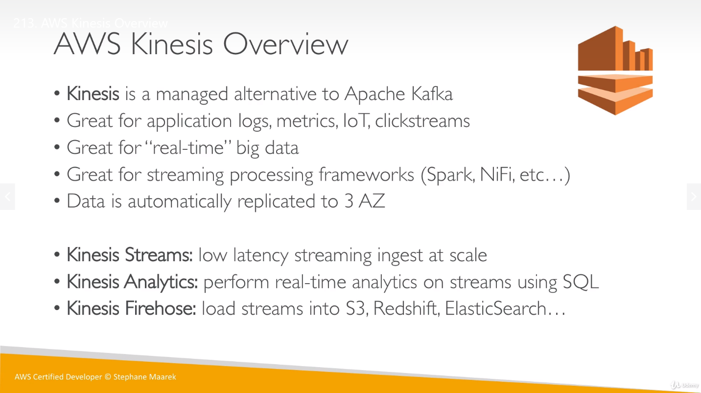

**How Kinesis works:**

Click Streams, IOT devices, Metrics and logs will be publishing data directly to the Kinesis Streams. Kinesis Analytics will take this data to do analysis/computation in real time. Once this analysis is done, to store data anywhere like in S3 bucket or RedShift etc., we use Kinesis Firehose.

**ClickStream:** A virtual trail that a user leaves behind while [surfing](https://www.webopedia.com/TERM/S/surf.html) the Internet. A *clickstream* is a record of a user's activity on the Internet, including every Web site and every page of every Web site that the user visits, how long the user was on a page or site, in what order the pages were visited, any [newsgroups](https://www.webopedia.com/TERM/N/newsgroup.html) that the user participates in and even the e-mail addresses of mail that the user sends and receives. Both [ISPs](https://www.webopedia.com/TERM/I/ISP.html) and individual Web sites are capable of tracking a user's clickstream

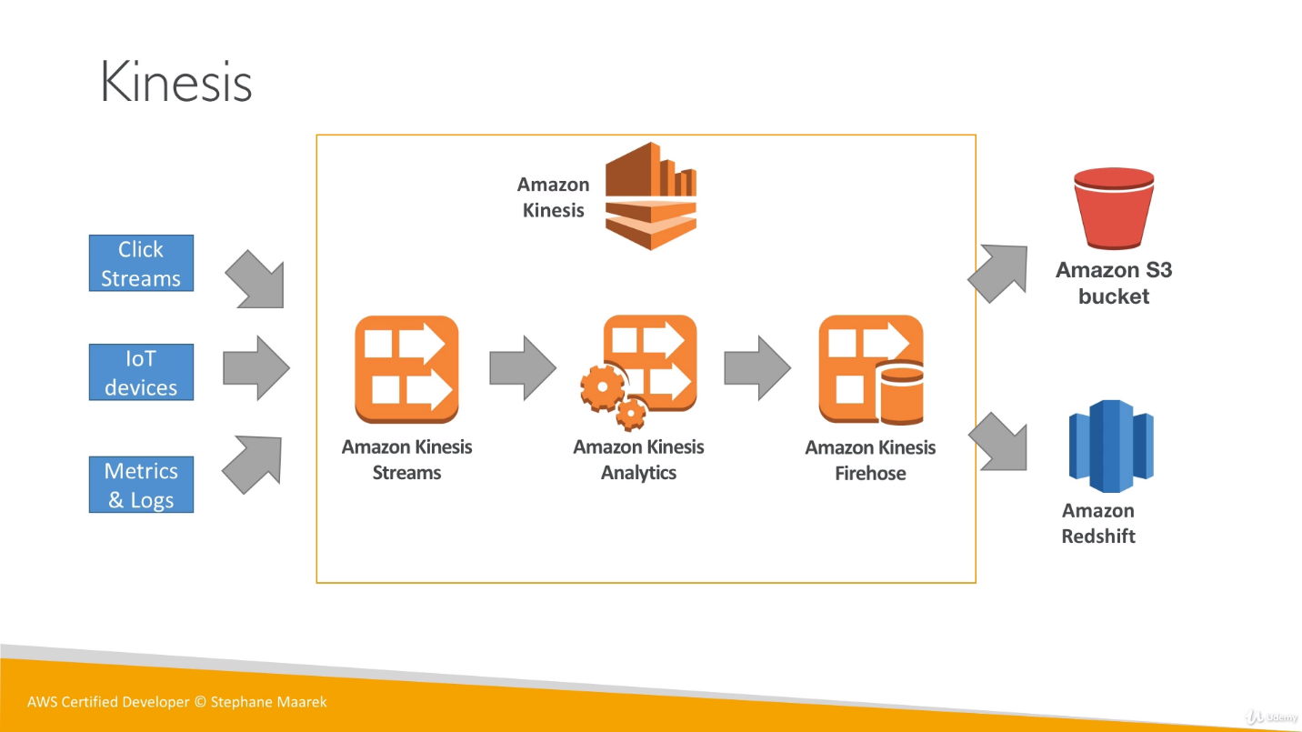

**Difference between Kinesis and SQS:**

In SQS, once the data is consumed it flush from queue but in Kinesis data will be still there and will expire after sometimes (based on data retention period), so we can reprocess or redeploy data if required. Kinesis is kind a pipeline not a database so once the data is inserted into it, can’t be deleted.

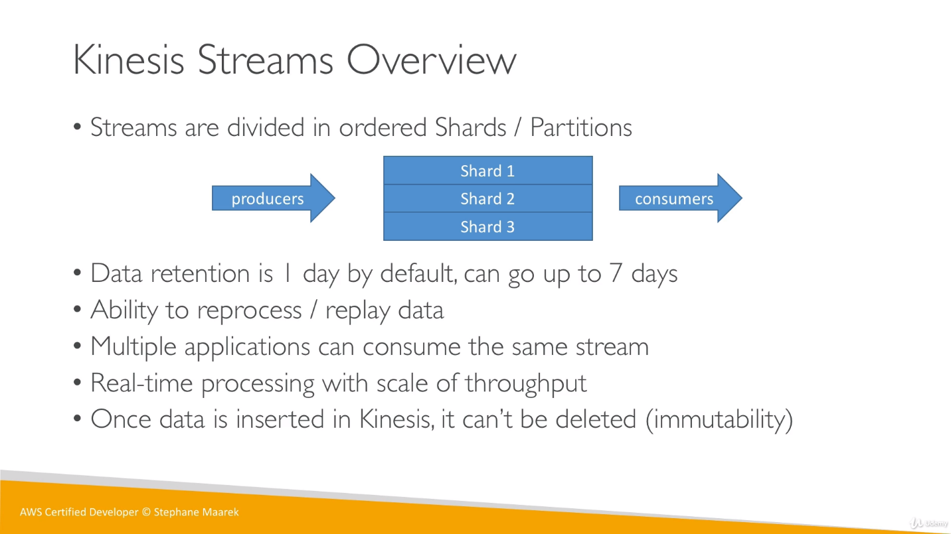

**Shard:** A shard is a uniquely identified sequence of data records in a stream. stream is composed of one or more shards, each of which provides a fixed unit of capacity.  One shard provides a capacity of 1MB/sec data input and 2MB/sec data output. (So, suppose if we need 6MB/S throughput the we need 3 shards) One shard can support up to 1000 PUT records per second. We will specify the number of shards needed when you create a data stream.

**Re-sharding and Merging:** Whenever we need more throughput and we are adding shard, it’s called re-sharding. If we are reducing shard, it’s called merging.

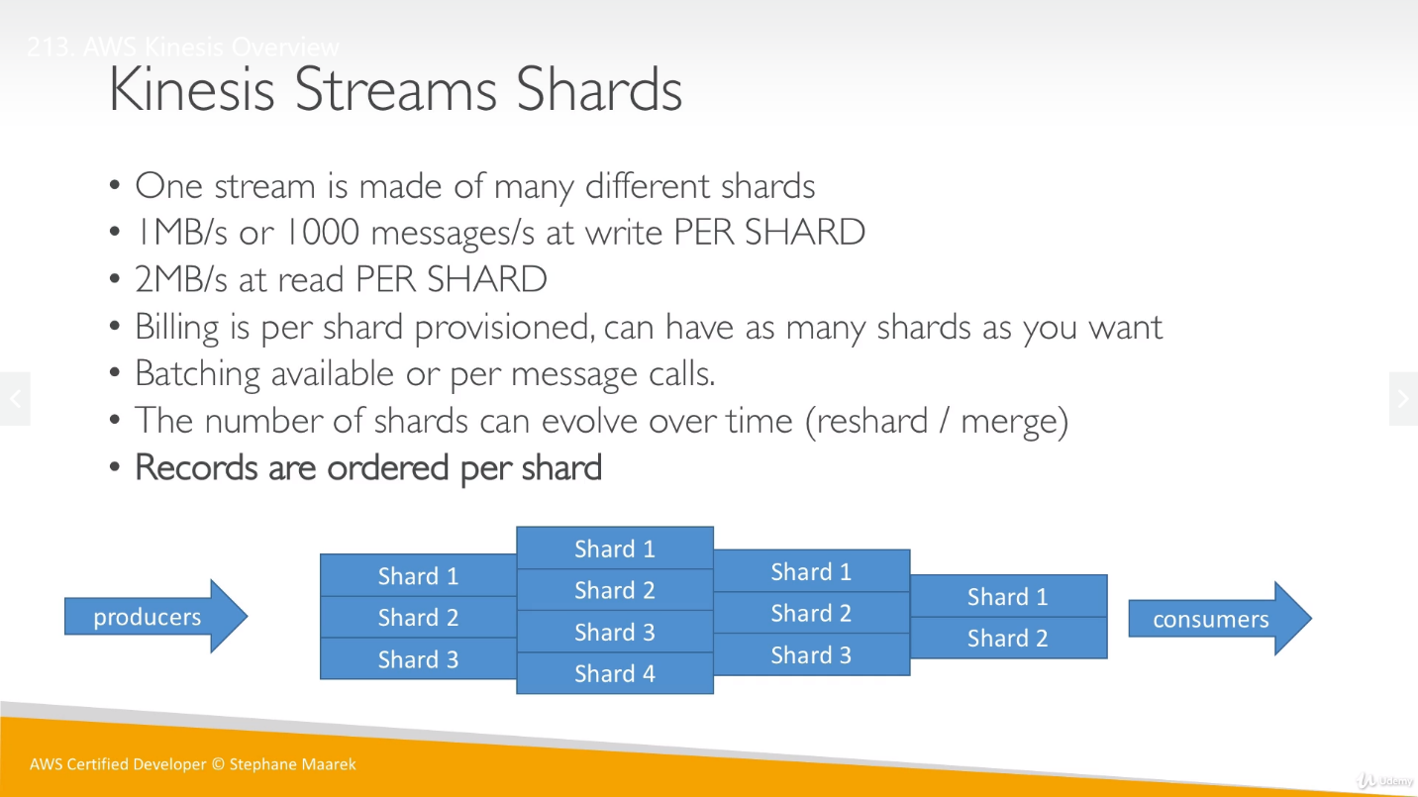

**PutRecord:**

The way that we are sending data from producer to Kinesis is known as PutRecord. We need to send data along with a partition key. Using this message key, data will know where to go (on which shard). Data will go only for one shard at a time.

Messages once send to shard, they get a sequence number, which is always increasing.

If we need to choose a partition key, we need to choose one which is highly distributed (else data will go to same shard so one shard will be overwhelmed, this is called hot partition or hot shard ).

For an example if we have 1 million users then user id is great key,

**AWS SNS:**

Amazon Simple Notification Service (Amazon SNS) is a web service that coordinates and manages the delivery or sending of messages to subscribed endpoints or clients. In Amazon SNS, there are two types of clients—publishers and subscribers—also referred to as producers and consumers. Publishers communicate asynchronously with subscribers by producing and sending a message to a topic, which is a logical access point and communication channel. Subscribers (that is, web servers, email addresses, Amazon SQS queues, AWS Lambda functions) consume or receive the message or notification over one of the supported protocols (that is, Amazon SQS, HTTP/S, email, SMS, Lambda) when they are subscribed to the topic.

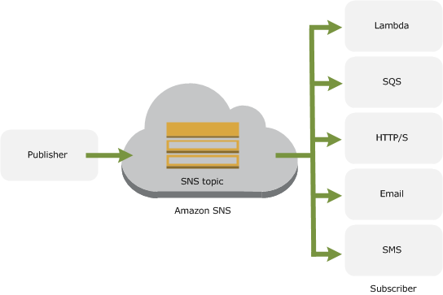

When using Amazon SNS, you (as the owner) create a topic and control access to it by defining policies that determine which publishers and subscribers can communicate with the topic. A publisher sends messages to topics that they have created or to topics they have permission to publish to. Instead of including a specific destination address in each message, a publisher sends a message to the topic. Amazon SNS matches the topic to a list of subscribers who have subscribed to that topic, and delivers the message to each of those subscribers. Each topic has a unique name that identifies the Amazon SNS endpoint for publishers to post messages and subscribers to register for notifications. Subscribers receive all messages published to the topics to which they subscribe, and all subscribers to a topic receive the same messages.

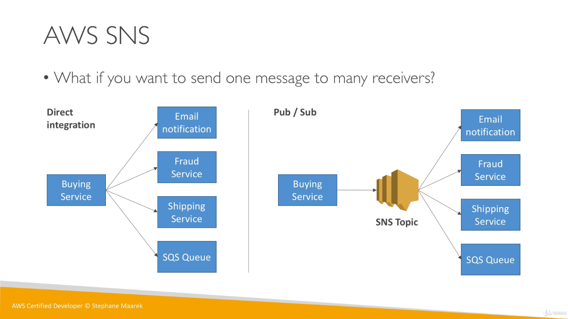

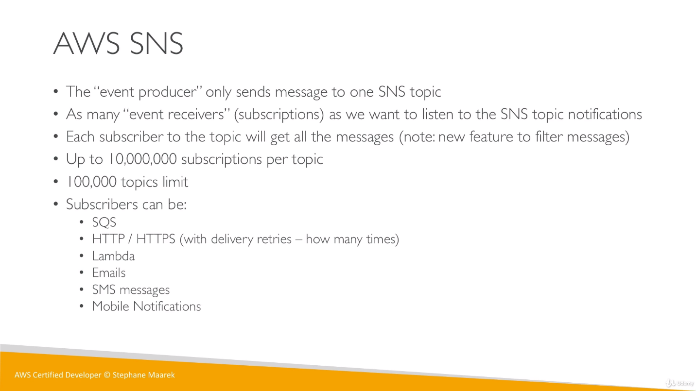

We can have up to 1 Crore subscription per topic and we can have up to 1 Lakh topic.

 The SNS call to publish a message to a topic is synchronous in that the call won't return until the message is successfully published. However, the call won't block until all subscribers have been notified. That part happens asynchronously.

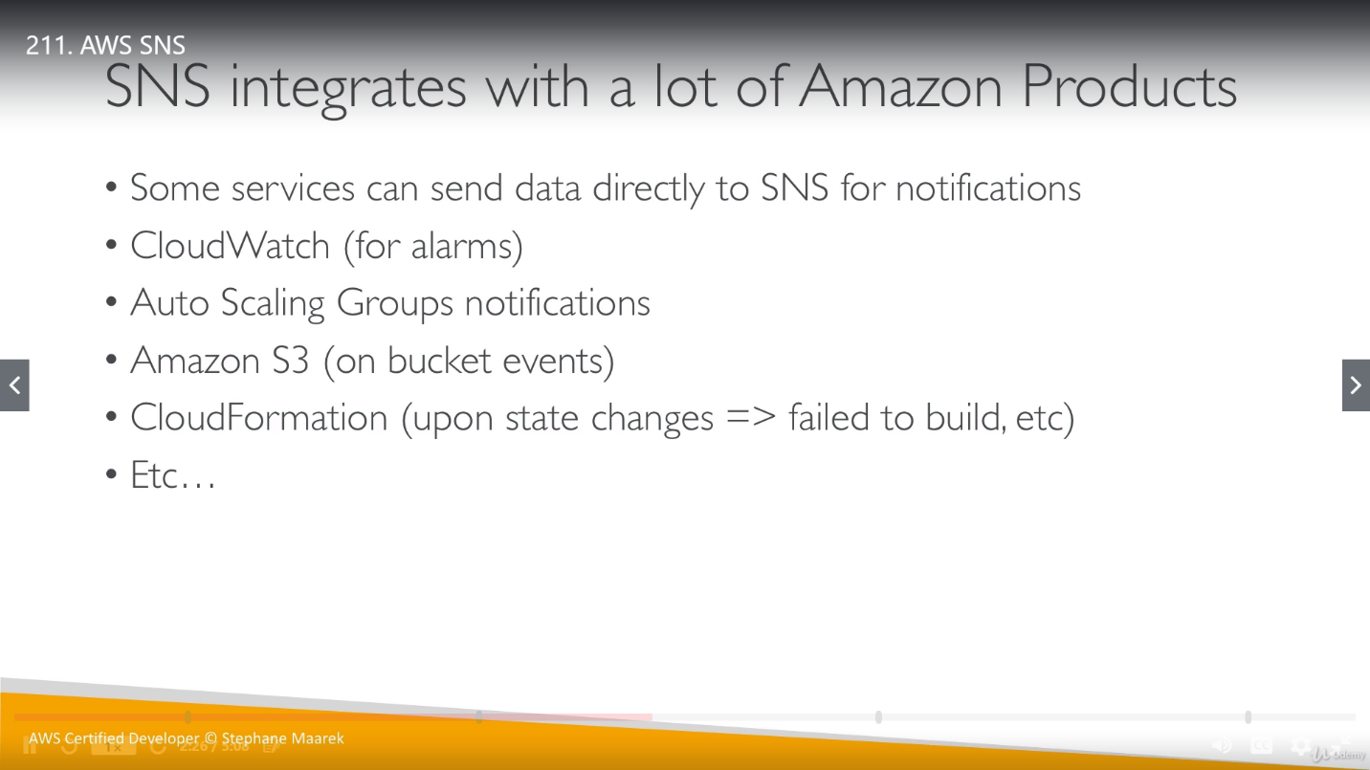

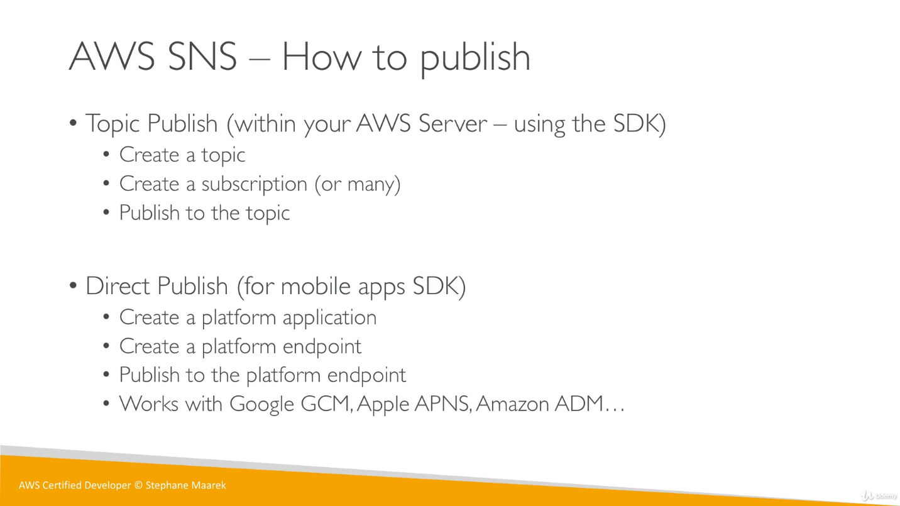

**SNS with SQS:**

If we want to publish data to many SQS queues, so push it once to SNS and received by SQS.

